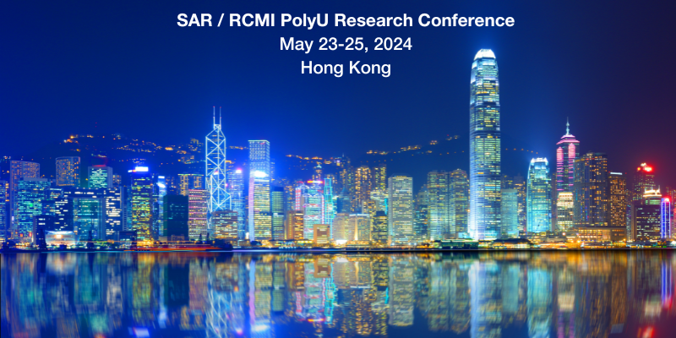

SAR/ RCMI PolyU International Research Conference: May 23-25, 2024, the Hong Kong Polytechnic University, Hong Kong SAR, China

Call for Abstracts
Bridging the Two Worlds: Engaging Traditional Chinese Medicine in Modern Health Care
______________________________________________
Abstract submission deadline: January 12, 2024

We are pleased to announce that SAR will be jointly organizing an upcoming conference with the Research Centre for Chinese Medicine Innovation (RCMI) of the Hong Kong Polytechnic University.

The SAR / RCMI PolyU 2024 conference will present a platform wherein researchers from various healthcare professionals and disciplines can share, explore, and develop novel research hypotheses and strategies for acupuncture and Traditional Chinese Medicine (TCM). The primary objective of this conference is to construct a robust bridge between the East and West, with the aim of advancing the scientific understanding and evidence-based clinical applications of acupuncture and Traditional Chinese Medicine (TCM). Our goal is to enhance patient outcomes and optimize health care delivery through this integration.

We seek to build bridges between basic mechanisms and precision clinical medicine, as well as ancient wisdom (e.g. personalized therapies) and modern technology (e.g. Artificial Intelligence). This fusion will not only honor the rich heritage of TCM but also pave the way for its evolution in the modern health care landscape.

Abstract submission
Abstracts are solicited for presentations in the areas of clinical research, basic science and research methodology pertaining to acupuncture, Chinese herbal medicine, and other modalities of Traditional Chinese Medicine including moxibustion, Tai Chi, Tui Na (massage), Qi Gong and complex lifestyle modification. We also welcome abstracts on novel education methods, care innovation/delivery to promote the collaborations between researchers and frontline educators and clinicians. Abstracts will be reviewed by the conference Scientific Review Committee and prospective presenters will be informed by February 13, 2024 as to whether their research has been accepted for oral or poster presentation.

Please upload your abstracts by January 12, 2024 to: https://softconf.com/n/sar-hk2024
Abstracts submitted after January 12, 2024 will not be considered.
美国针刺研究学会与香港理工大学中医药创新研究中心
联合举办学术会议
2024年5月23-25日
香港理工大学 中国香港
摘要征集启示
会议主题「架起两个世界的桥梁：将传统中医融入现代医疗保健」
摘要提交截止日期：2024年1月12日
美国针刺研究学会（SAR）与香港理工大学中医药创新研究中心（RCMI）将于2024 年 5 月 23-25 日联合举办一次主题为「架起两个世界的桥梁：将传统中医融入现代医疗保健」的会议，会议地为中国香港特别行政区香港理工大学。
本届会议旨在为不同医疗专业学科的研究人员提供一个交流分享的平台，以探索、发展针灸和中医的新研究假设和新策略。本次会议的主要目标是建立一座联系沟通东方与西方的坚固桥梁，促进对针灸和中医学的学科认识及循证临床应用，以这种融合的形式提高对患者治疗疗效、优化医疗保健服务。
我们希望将基础机制和精准医疗、传统智慧（例如个性化治疗）和现代技术（例如人工智能）相互结合。这种结合不仅遵循了中医丰富的传统文化，而且在现代医疗保健领域的发展中具有重大意义。
摘要提交
摘要征集内容涉及针灸、中草药以及艾灸、太极、推拿（按摩）、气功和复杂的生活方式改变等其他中医疗法的临床研究、基础实验研究和研究方法。此外，我们还接受有关新颖的教育方法、提供或更新护理方式的摘要，以促进研究人员与一线教育工作者和临床医生之间的合作。摘要将由会议科学评审委员会进行评审，摘要递交者将会于 2024 年 2 月 13 日之前收到通知，被告知是否被接受进行口头演讲或海报演示。
请在 2024 年 1 月 12 日之前将您的摘要(只限英文)上传至：https://softconf.com/n/sar-hk2024
2024 年 1 月 12 日之后提交的摘要将不予考虑。
SAR/RCMI香港理工大学联合举办学术会议
2024年5月23-25日
中国香港

